The Work Number aka TWN (Equifax)
Completed by E360 Help Desk
Screen shots, with identifier above the screen shot, so QC person(s) can identify what the screen shot is for. Emails requesting account set up/termination must be added to the ticket for audit purposes.
Effective 11/1/22 – Do not issue an account to any new hires with express permission from NPS.

Setup:
Log into https://secure1.verifier.theworknumber.com/verifier3/Account/LogOn?ReturnUrl=%2fverifier3%2f
Click on the settings wheel then “User Management”
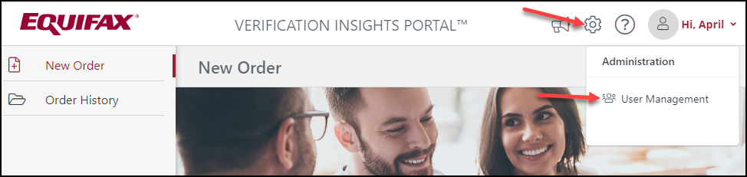

Click “Add User”
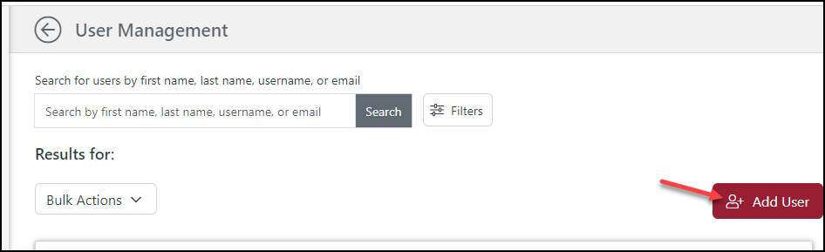

Enter highlight fields. User(s) name is in scheme of “FirstName.LastName”.
Click “Continue”
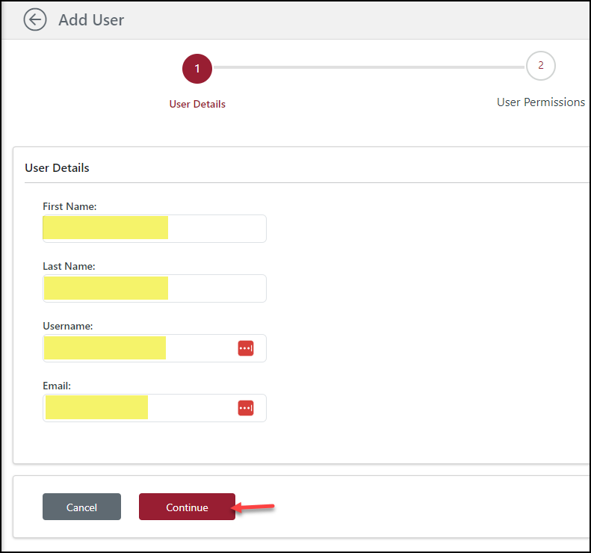
Choose Organization>Click select on the “Highlands Residential Mortgages Organization ID 82989”
Click Save Selection
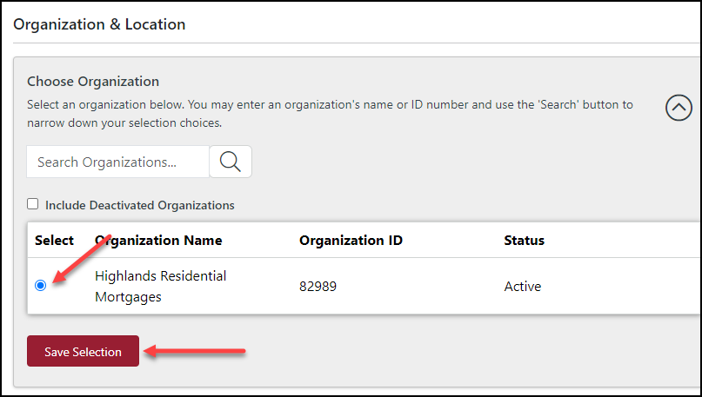

Choose Location>Select “Highlands Residential Mortgage Location ID 339552”
Click “Create User”
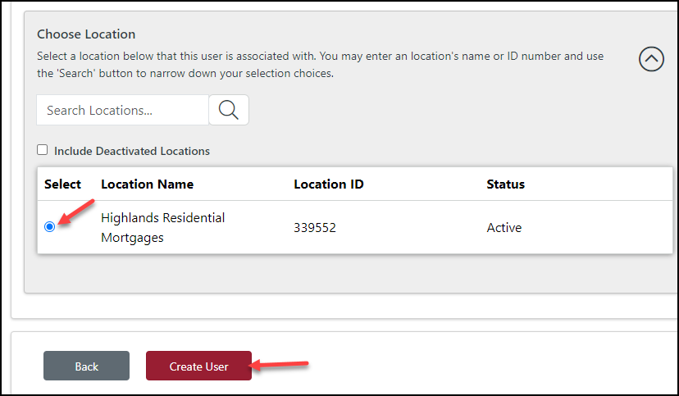
The user will be emailed activation link from Equifax, the user’s name is delivered through Last Pass

